Valley of the Yosemite

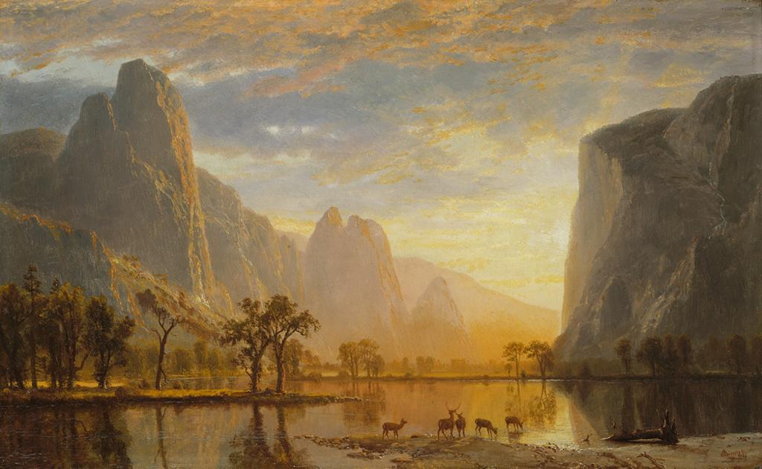

Albert Bierstadt, Valley of the Yosemite, 1864, Oil on Paperboard, (30.16 cm x 48.89 cm)
The Museum of Fine Arts, Boston, MA

State and national governments were eager to broaden their reach by encouraging industry and thereby settlers, to relocate in the west; “A few provident grants were made, but ‘giveaway’ was the rule, and prodigality reached its peak between 1850 and 1871 when an area larger than France, England, Scotland, and Wales was granted to the railroad companies.” (Udall, 1965, p.57) The expansive range of unsettled land on the western frontier gave rise to the Myth of Superabundance. Industry responded to this conducive atmosphere with exuberance and the forests began to fall, mountains were washed away from hydraulic mining. As the obscenities compounded, there began to be stirrings of disgust. Many who protested were authors and writers associated with the Romantic Movement.
“The self-conscious aim of Life is to find expression, and that Art offers it certain beautiful forms through which it may realize that energy.” (Oscar Wilde)
The American landscape had received its first glimmer of appreciation when captured on canvas by the artists of the Hudson River School. The influence of Romanticism was evident in the choice of natural elements placed as the center of interest, in settings nearly or totally devoid of humanity. Vast stretches of untamed wilderness, bathed in golden light, overseen by wide open skies, these were the purlieu of Hudson River painters. Their casting of nature in such a pleasing depiction was a distinct progression from the antagonistic and fearful viewpoint of early settlers; “The Puritans and to a considerable extent their neighbors in the plantations to the south, went to the wilderness in order to begin the task of redeeming the world from its wilderness state.” (Nash, 2014, p.35) As the new world expanded, these artists followed the sun into the west in search of new and miraculous landscapes. Their goal was to depict the glorious wilderness before it fell victim to the relentless progression of industrial servitude.
Originally a member of the Hudson River School, Albert Bierstadt’s extensive travels and his affinity for western landscapes helped to define a new class of painters. The group was dubbed the Rocky Mountain School and included many other artists, like Thomas Moran, who began their careers in the Hudson River Valley. The painting I chose was Valley of the Yosemite, (Bierstadt, 1864). Many elements in this work are inherited from Bierstadt’s earlier experience. The canvas is encompassed almost entirely by the tremendous mountains which surround the Merced River. The lithic structure is a study in cool shadows and warm reflected light. The horizon line is dropped very low, occupying only the lower quarter of the painting. It is here in the red-orange reflection that we see the serene surface of the river and the valley’s few animate inhabitants. A family of deer sip languidly from the cool water in the foreground. The overwhelming stillness is broken only by the sweeping, cloud filled sky. The grand proportions reduce the viewer to a position of awestruck insignificance.
The artists and writers who were capable of encapsulating these wilderness experiences deserve much of the credit for their preservation. It is their words and images that initiated remorse over the disappearance of the unique American landscape. Those who had never seen such majesty in person lived vicariously through these visual and verbal expressions. As these impressions permeated the citizenry, proposals arose for the preservation of untouched territory. Our generation owes a great debt of gratitude to these Romantic souls. If not for them, industry might have prevailed, tracks been laid and the whistles of locomotives would pierce the quiet solitude of Yosemite.

References

Bierstadt, Albert. (1864). Valley of the Yosemite. [Painting]. Retrieved from http://library.artstor.org.ezproxy1.lib.asu.edu/library/iv2.html?parent=true

Nash, Roderick Frazier. (2014). Wilderness and the American mind. New Haven, CT:
Yale University Press.

Udall, Stewart Lee. (1964). The quiet crisis. New York, NY: Avon Books.

