Jennifer McAninch

Renaissance Artwork Analysis
The Chess Game
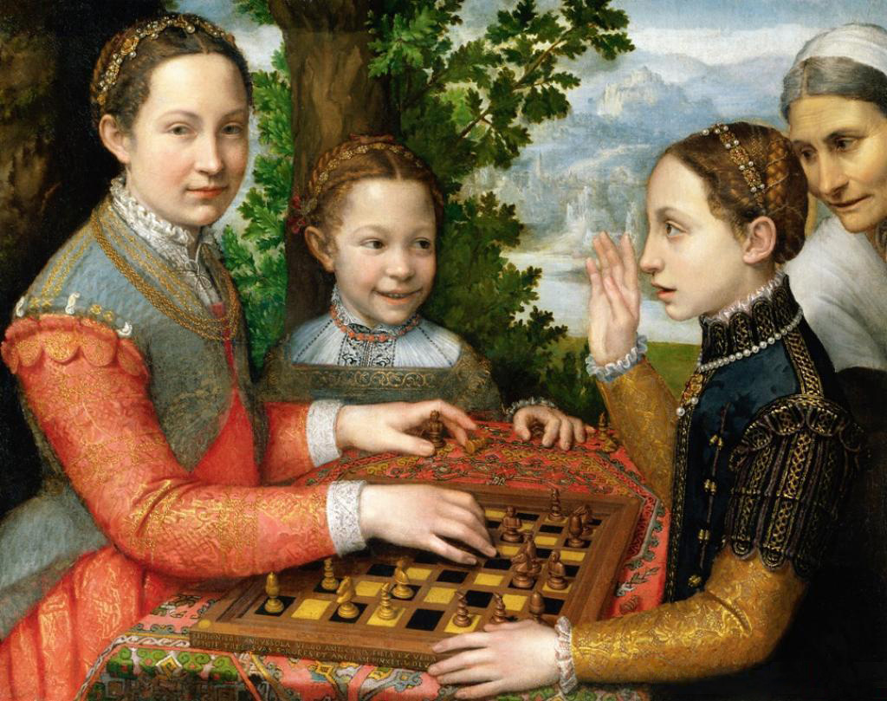
Sofonsiba Anguissola, The Chess Game, 1555, Oil on Canvas, (70 x 94 cm)
Museum Narodowe, Poznan, Poland

This painting, titled The Chess Game, was completed by Sophonisba Anguissola in 1555, when she was twenty-three years old. At that age she had already completed her training with Bernardino Campi and continued the expansion of her skills in Rome. During those years, Anguissola completed several works including her Pieta (c. 1550) and her Self Portrait (1553). According to scholar Ilya Sandra Perlingier, she may have also completed the painting Bernardino Campi Painting Sofonisba Anguissola (c. 1550) prior to beginning work on this canvas. The Chess Game was undertaken shortly after she returned to Cremona from her studies in Rome. Considering the fact that Anguissola's career spanned over seventy-five years, this work was produced at a relatively early stage. Regardless of her youth, she had already developed extensive skills in painting and asserted stylistic independence from her teachers. The Chess Game highlights the confidence of the young artist in her choice of complex subject and sophisticated composition.
Portrayed here are three of Anguissola's younger sisters; Lucia, Europa and Minerva. On the far right is a servant from the Anguissola household. (This servant also appears in a self-portrait painted by Anguissola in 1561.) Beginning on the left of the painting is Lucia, the winner of the game. She gazes directly at the viewer with a serene expression while forwarding the final move. She is dressed in a salmon colored gown with a chambray overdress, both with intricate gold embroidery. Her chemise has a ruffled collar and lace at the cuffs. Continuing to the right is Europa, the youngest sister in the painting, who follows the action of the game. Her gown is similar in color to Lucia's overdress, with embroidery on the chemise and gown. Her necklace is also salmon-colored and provides a visual link between the two sisters. Other indications of their close connection are physical proximity and Europa's obvious delight in her sister's triumph. Across the chessboard is Minerva, she holds up a hand in a gesture of protest or defeat. Her attire is more somber than her sisters', with a high neckline and darker coloring. It is equally fine, with a black bodice and sleeves heavily embroidered in gold. Over Minerva's shoulder, the servant monitors the action of the game. The older woman is attired in traditional simplicity with a crisp white cap and collar.
Several aspects of the painting reflect the artist's maturing style, "Lucia's left hand is done in a similar 'square-U' that Anguissola rendered in her Self-Portrait at the Clavichord; and there is an intent gaze in her almond-shaped eyes. All three girls have rosy, youthful complexions done in tremendous contrast to the old woman's face." The careful treatment of costume and textile that is evident here would continue to be an earmark of Anguissola's style throughout her career. There are also traditional components of Italian painting that she has incorporated. The distant view of the hillside is rendered in sfumato, with shapes that disintegrate as they expand into the distance. Set in contrapusto to the fading countryside, the tree close outside the window is very specific and can even be identified as a white oak due to careful depiction of the leaves. The subject of the painting is unusual for the time. The domestic setting is populated by expressive figures captured in a moment of casual enjoyment. The infectious smile on the face of Europa has no real precedent. It is her delight that makes the painting truly unique and provides the truest sense of the close relationship between the Anguissola sisters.
One other aspect of the painting which is not as readily apparent today as it would have been to a contemporary audience, involves the game the sisters are playing. Chess was long considered a game of strategy and intellect. Women are rarely depicted playing, and never shown in absolute triumph. That both conventions are broken here suggests something more momentous than a simple game. It reflects the unconventional attitudes toward both intelligence and education that existed within the Anguissola household. It has been suggested that the painting is an affirmation of female agency, "Yet one may ask whether the Aguissola sisters are playing only chess. For if playing the spinet or virginal is a metaphor for self-possession and creative achievement, playing chess may represent something similar, particularly when the game's only female piece has been elevated to a position of great power." In choosing to depict chess, Anguissola confirms the abilities of her sisters. They not only play, they excel and enjoy the intricacies of the game.

Ilya Sandra Perlingieri, Sofonisba Anguissola: The First Great Woman Artist of the Renaissance, (New York: Rizzoli, 1992), 48
Ilya Sandra Perlingieri, Sofonisba Anguissola: The First Great Woman Artist of the Renaissance, (New York: Rizzoli, 1992), 87
Mary D. Garrard, "Here's Looking at Me: Sofonisba Anguissola and the Problem of the Woman Artist," Renaissance Quarterly, Vol. 47, No. 3 (Autumn, 1994) 569

