Jennifer McAninch

Baroque Artwork:
Judith and Holofernes
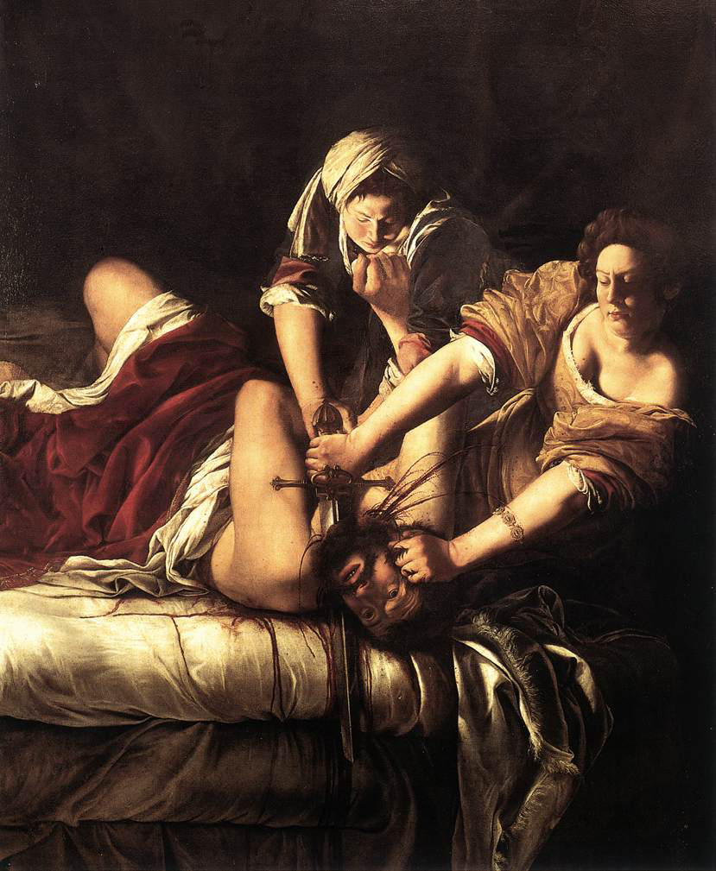

Artemesia Gentileschi's Judith and Holofernes (c 1620), which is housed in the Uffizi Gallery, has a storied history. Gentileschi was not quite thirty when the painting was completed, but by that time she had an extensive oeuvre. The Uffizi Judith was a direct revision of one of her earlier paintings and a return to a familiar theme. The painting was commissioned by the Grand Duke of Florence, Cosimo II de' Medici, but it was not well received. Gentileschi did not receive payment until after the death of the Duke and only then with the assistance of Galileo Galilei. The painting languished, relegated to an obscure location within Palazzo Pitti. Contemporary critics of the painting pointed to its visceral detail as gruesome and improper. However, the actual motivation for this mistreatment was more closely related to the gender of the artist than to the subject matter and the manner in which it was depicted.
There was nothing exceptionally unusual about decapitation in either Renaissance or Baroque art. Quite the opposite was true, especially in Florence where there were several popular precedents. Donatello's David (c. 1430), standing with his foot resting on Goliath's dismembered head, was a symbol of the Florentine Republic. Benvenuto Cellini's Perseus with the Head of Medusa (1545) depicts the hero standing on the corpse of the gorgon, holding her oozing head aloft. With these and many more examples in place around the Florentines, their dislike of Gentileschi's Judith begs further explanation; "Through slight but significant reworkings of the composition, the artist has heightened the very qualities likely to have induced masculine dread. In pitch darkness, outlined by a cold spotlight, two determined women efficiently decapitate a stunned and struggling man." Though apparently unfazed by macabre examples of masculine heroes vanquishing enemies, when the saber rested in the hand of a woman, the Florentine fathers became decidedly anxious.
It is difficult to determine if any current action might properly compensate for centuries of neglect toward both the painting and the painter. Thankfully some of the prejudice that kept this painting in the shadows has now been addressed. It is the only painting by a female artist that is listed as a "Must See Masterpiece" in the Uffizi catalog. Gentileschi's Judith now resides in a Uffizi salon dedicated to the followers of Caravaggio, also known as the "Caravaggisti." The painting represents a return to the dramatic tenebrism that characterized much of her early work. The impassioned moment captured in the scene is characteristic of the Baroque focus on theatricality. The subject of the painting is the biblical character Judith, whose righteous execution of the Assyrian general makes her the savior of her city. She is assisted in her endeavor by her stalwart maidservant, who determinedly restrains Holofernes.
The dark fabric of the tent creates the background of the painting. Around the figures there is deep shadow, focusing all attention on the scene unfolding in the center of the canvas. At the left of the painting, Holofernes' legs writhe against the crisp white sheets, creating a diagonal which continues along his arm and finally culminates at his head. The red velvet bedclothes that cover him from thigh to chest echo the deep color of his blood. In the center of the composition is the maidservant with her hair wrapped in a white headdress. She physically overpowers the drunken general and does not release him despite the clutching hands that fight to fend her off. She has prepared for the moment by rolling her sleeves, revealing the strong, tense muscles of her forearms. She stares unflinchingly as her mistress strikes the fatal blow.
The figure of Judith, at the right of the painting, dominates the foreground. Her expression is one of extreme concentration and absolute resolve. Her tenacious grip on both the head of her enemy and the hilt of her sword, inspire confidence that she will succeed in her task. Her arms form another diagonal which also leads to the head of Holofernes. Defined by strong linear implication, the center of action is undoubtedly occurring where the steel blade meets flesh. Gentileschi has effectively frozen a moment in time. She has captured the point of no return, when death is imminent, but not yet accepted. Holofernes continues to struggle uselessly against his undeniable fate. Judith leans slightly away, as if judiciously avoiding the copious flow of blood, which spurts forcefully as she dispatches the great enemy of her people. Yet even in this lurid moment, no doubt or reluctance shows in her expression.
The three figures in the scene, combined with their interactions and expressions, seem especially well served by the artist. It is challenging to imagine any technique or approach which could enhance the sensational effect. Few works of art have initiated more debate between admirers and detractors; "It has been variously seen, and this is an incomplete list, as an image of sadism, sacred ritual, irreligious profanity, self-portraiture (both psychic and physical), heroic feminism, misogyny, murder, sexual intercourse, castration and penis envy, childbirth, and even science..." There have been numerous assertions regarding the psychological motivation of the artist. Experts in various fields infer connections of the Judith story to Gentileschi's rape and therefore view the Uffizi Judith as her visual catharsis. Despite the tempting correlation, the artist never recorded any such association. To contemplate the extent to which she responded on a personal, emotional level might be intriguing, but can never be established with any kind of accuracy. The suggestion of surety is an illusion, which perhaps speaks as much of the viewer as it does of the artist.

Bibliography
Garrard, Mary D. Artemisia Gentileschi: The Image of the Female Hero in Italian Baroque Art. Princeton, N.J.: Princeton University Press, 1989.
Bal, Mieke. The Artemisia Files: Artemisia Gentileschi for Feminists and Other Thinking People. Chicago: University of Chicago Press, 2005.

Mary Garrard, Artemisia Gentileschi: The Image of the Female Hero in Italian Baroque Art (Princeton, N.J.: Princeton University Press, 1989), 323.
Bal, Mieke. The Artemisia Files: Artemisia Gentileschi for Feminists and Other Thinking People (Chicago, Illinois: University of Chicago Press, 2005), 79.

