The Death of Socrates
Jacques-Louis David, 1787

Jennifer McAninch

February 28, 2015

Throughout history there arise definitive voices which speak uniquely and eloquently of their generation. They reflect time, place and culture so perfectly that those far removed are given a new understanding by exposure to their seminal works. The message resonates whether these voices manifest through the written word, orchestrated melody or the visual arts. Jacques-Louis David had such a voice. His paintings provide exemplary insight into the tumultuous times in which he lived. The artist’s studies in Italy resulted in the development of a new style, inspired by both the aesthetics and the philosophies of the ancient world. The style, known as Neoclassicism, was an outright rejection of the celebrated opulence and frivolity of the Rococo. In the building political and economic turmoil of aristocratic France, the work of Jacques-Louis David became more than paint and canvas. The images helped sound a call for Revolution.
One such painting, The Death of Socrates (1787), is a quintessential expression of Neoclassicism and the embodiment of the artist’s aspirations for an enlightened, republican society.
Formally established in 1648, the Académie Royale des Beaux Arts governed all aspects of the French art world. At the time of its creation, the Baroque style was pervasive. It extended not only through painting and sculpture, but overtook decorative art as well. Most artwork produced in the Baroque style has the characteristic “painterly” effect described by Heinrich Wölfflin, but there are notable exceptions. Though he is considered a Baroque artist, Nicolas Poussin was a stringent follower of the classical style. His paintings have a linear quality and clarity that were abandoned by many of his contemporaries (Fig. 1). Poussin was mildly successful in his lifetime, but his unique stylistic interpretations would fade as the popularity of intricate ornamentation and pastel colors increased. The new style that developed was termed the Rococo. The gravity of Baroque art was replaced with levity currently en vogue with aristocratic patrons. This new style was populated with the flushed pink flesh of lovely ladies as they rollicked in idealized landscapes. Artists continued to employ mythical subject matter, but only as an allusion. Their figures no longer wore classical costume and were not set amidst ancient architecture. Instead fabrics of silk and lace in current fashions covered, and often uncovered, sensuous bodies painted in lush European woodlands. Though many artists painted in the Rococo style, perhaps the most successful was François Boucher. His long career included paintings with subtle shadows and infinite grace which flattered his subjects and influenced other academicians for decades (Fig. 2).
Traditionally the citizens of France had been divided onto three categories, or estates. The First Estate was the clergy, the Second Estate was the nobility and the Third Estate included everyone else. During the nearly sixty year reign of King Louis XV, the French monarchy was faced with a myriad of challenges. Sporadic victories against British, Dutch and Austrian forces were tempered with comparable defeats. The battles were costly and the expense depleted both the treasury and the confidence of the people. The Age of Enlightenment had caused a shift toward reason that permitted challenges to the “God given” authority of the king. Stepping into the role of his antagonists were the members of the Parlement de Paris, a strictly judicial body formed with members the Second Estate. Though they had no legislative power, they did have the duty to register, and therefore, enforce those laws dictated by the monarchy. The most contentious disagreements arose from new tax laws which, for the first time in history, were imposed on the First and Second Estates. These conflicts would result in Parlement refusing to register new laws, including those that restricted inflation of the cost of grain, a decision that would come to have tragic consequences.
When Jacques-Louis David was born on August 30, 1748, his parents were little more than teenagers themselves. The life of the young David would not be predicable or stable. His father was Louis-Maurice David, who came from an established entrepreneurial family. His mother was Marie-Genevieve Buron, whose family connected her to notable artisans and artists, including François Boucher. Louis-Maurice and Marie-Genevieve were married in 1746: “Thus, on his father’s side David came from the Parisian bourgeoisie that sought to improve their position in the world through hard work and talent – but was still only the Third Estate – and, on his mother’s side, from the milieu of artisans where there was no separation between artistic creation and the actual manual labor involved in its execution.” By the time of his marriage, Louis-Maurice had taken over direction of his family’s successful mercantile business. Given this auspicious beginning, the first upheaval Jacques-Louis David would endure was decidedly unexpected. It was brought on by the formidable temper of Louis-Maurice, who, in 1757 was killed in a duel.
After the death of his father, his mother relinquished the care of her nine year old son to her brothers and left for Normandy. His uncles encouraged David to consider practicing law or studying architecture, but he was a mediocre student and had no interest in either. According to an excerpt from his unfinished autobiography, David persuaded an aunt to intercede with his uncles. He convinced her that he was determined to be an artist and requested an introduction to his distant relative, François Boucher. The tremendous success enjoyed by Boucher had earned him the title “First Painter to the King,” and the adoration of the king’s mistress, Madame de Pompadour. Boucher’s paintings had helped define the sumptuous Rococo Style. When his young cousin was brought before him, he sent the boy to study with Joseph-Marie Vien, professor at the Académie Royale de Peinture. In 1764, at the age of sixteen, Jacques-Louis David began his formal artistic studies. Vien encouraged a return to the classics and a careful inspection of the natural world (Fig 3). He brought live models into the studio as subjects for his students. Though he was surrounded by this push toward classicism, David’s early paintings were influenced more by the work of Poussin than that of the Renaissance. His composition and linearity were taken almost verbatim from the French Baroque artist. For influences on coloring, he looked to his relative, Boucher.
Two years after his acceptance into Vien’s studio, David entered the Académie Royale des Beaux Arts. The Academy followed a strict hierarchy when it came to painting. At the bottom of the scale was still life painting. On the opposite extreme was history painting. David was determined to paint in the highest order, but his initial work was uninspiring and failed to earn any accolades. Still heavily influenced by his heroes, David struggled to find his artistic voice. The established path for artistic training required work in the studio of a mentor and acceptance into the academy for training in drawing. An artist could not progress further without studying the classics in Italy. To get there, one had to compete: “The procedure of selection is well known: sketch, painting from the nude, and the final competition en loge, in a separate room. The winners have the right… to a three year stay in Rome.” Each year he would enter the competition for the Prix de Rome and year after year he was rejected. The Academy was unimpressed by David, and he became increasingly resentful of the authority the academicians wielded. Finally, in 1774, David won first prize and was given the Prix de Rome (Fig 4 shows David’s submission). This enabled him to travel to Italy and begin his studies in earnest. His award coincided with the appointment of Vien as Director of the French Academy in Rome.
The same year that David traveled to Rome, France crowned a new king. Louis XVI was the grandson of the previous monarch and inherited much of the discord that had been directed at the throne. He attempted several reforms based on Enlightenment principles, including the instigation of a new tax code, but was confronted with opposition from much of the aristocracy, in particular the Parlement. Another grand struggle was underway between the king and his nobles. Once again, new laws were stymied. Louis’ financial support of the American colonies in their battle for independence further depleted an already insufficient treasury. Grain prices had risen to the point that many could not afford bread, the staple of the French diet. Coupled with dismal harvests, the results were cataclysmic. Death from starvation became a reality for ordinary citizens, while at Versailles the sumptuous banquet continued unabated. France found itself in a quagmire, stuck in a pattern of failure, relying on the king for salvation and holding him ultimately accountable for each error in judgment: “The result was government instability and the triumph of faction. Louis XVI also failed to give strong leadership, allowing ministerial rivalries to override commitment to long-term policies for reform, particularly in the areas of finance and the economy” The political infighting inspired many in the Third Estate to seek representation in the government. No longer satisfied that the crown had the best interests of the people at heart, whispers turned to shouts of the word “revolution”.
Meanwhile, in Italy, Jacques-Louis David was developing a new artistic approach. He was gaining a new appreciation for the ancient world. For the first time, he was exposed to the clarity of form in the work of Renaissance artists like Raphael and Michelangelo. Also significant to artists studying in Italy were the ongoing excavations at Herculaneum and Pompeii, which in addition to yielding examples of Hellenistic bronze statuary, provided the finest examples of classical painting ever discovered. David began producing volumes of drawings taken directly from subjects found in ancient sculpture and architecture. He faithfully copied the leading artists of the Renaissance and Italian Baroque. Though at first he resisted the influence of what he saw in Italy, in time he would completely abandon all he had learned in the academic style in favor of his new vision. David stated, “The scales fell from my eyes…. I understood that I could not improve my style because its underlying principle was false and that I had to begin by repudiating everything I had once thought to be beauty and truth.” His new style was void of embellishment and painterly subterfuge. Figures were modeled with forms that seemed carved from marble. Ancient architecture replaced intricate landscapes and background was restricted to the simple surfaces. David honed his new approach until he felt it was mastered. He then began to plan his return to Paris, confident that his new approach would set the world afire.
Jacques-Louis David had his initial showing at the 1781 Salon and was a resounding success (Fig 5 shows David’s submission). To build upon the lessons learned in Italy, he traveled to Flanders to study the masterful coloration of Rubens and the photorealistic clarity of the Northern Renaissance Style. His return to Paris was marked by his 1782 wedding to Charlotte Pécoul, daughter of a wealthy building contractor. David continued to build on his artistic successes and received many lucrative commissions. In 1783 he was admitted as a full member of the Académie Royale. In 1784 he returned to Rome with the intention of reconnecting with antiquity. He began the initial drawings for a painting that would incorporate more than simple images of the ancient world. In The Oath of the Horatii (1784), (Fig.6) David explored the concept of sacrifice in service of the state. Three statuesque sons address their father and vow an oath to die for Rome. When the painting was complete, it was everything David had hoped for: “The stark simplicity, the clarity of the arrangement, the authority of the attitudes, the strength of the colors, as well as the intensely emotional contrast between the sacrifice and the grief dazzle the eye and speak to the soul.” The painting was displayed in Rome and David was unanimously lauded as the finest painter in Europe. He sent the painting on ahead of him and reserved a prime place for the 1785 Salon exhibition. Once again, David returned to Paris in triumph. The theme he had chosen fit perfectly with underlying political currents and was viewed by some as a call to arms.
The situation in Paris began to decline rapidly after 1786. Famine began in earnest following an extended period of bad weather and poor harvests. Rumors began to circulate that aristocrats were hoarding supplies of grain. Attempts at reform were hindered by an entirely uncooperative Parlement and an impotent king. The third estate began to demand recognition and government representation. The monarchy had supported American independence against Britain but refused the same rights to the citizens of France. This inconsistency was not lost on a young idealist named Maximilien Robespierre. His voice joined others in reminding the monarchy of the principal philosophies of the Enlightenment. They championed the work of Montesquieu, whose call for a separation of political powers inspired the U.S. Constitution. Pamphleteer Thomas Paine, visited France and began to support independence there as he had done successfully in America: “He collaborated with a small group (including Nicholas Bonneville and the Marquis de Condorcet) to produce a republican manifesto that was pasted on the walls of Paris, to the outrage of most members of the National Assembly.”
It was in this moment that the art, culture, history and politics of Jacques-Louis David crystalized into an inseparable conglomerate. Here his voice reached its pinnacle and ultimately reflected the ideals of his generation. He unrelentingly established the Neoclassic cannon and redefined the style as his own. The painting he produced was The Death of Socrates (1787) (Fig 7). The theme was taken from the writings of Plato and focused on the manner in which his mentor, Socrates, met his demise. It became a popular theme for artists after it was suggested by Diderot in his Traité de la Poésie Dramatique: “Until then his friends had been able to contain their anguish, but as he raised the cup to his lips they could control themselves no longer.” David chose to illustrate the specific moment Diderot describes, when the philosopher raises the cup of hemlock and those around him react. The subject of the painting spoke to the revolutionary movement in several significant ways. Socrates was charged with corrupting the youth of Athens but was ultimately condemned for challenging political and religious authority. Offered the opportunity to recant his teachings and thereby avoid sentencing, he flatly refused. He choose instead to stand beside his methods and set an example of moral certitude for his followers, to die for what he believed to be truth, rather than live what he knew to be a lie. Plato tells us that Socrates was stoic and strong in the face of certain death. The circumstances of the story and characteristics of its hero have made the philosopher immortal. His immortality made him an archetypal hero of revolutionary France.
David intentionally structured The Death of Socrates to embody the virtues of rationality, stability and clarity. In every stroke of the painting, his objective is reinforced. The title of the painting describes the moment portrayed and explains the gravity in the expressions of the figures. The overall composition of the painting directs the focus slightly off center to the right. The figure occupying that space is the Greek philosopher Socrates, who gestures dramatically and reaches for the cup located in the geometric center of the painting. Socrates is surrounded by supporters, some of whom grieve, others who are stoic. The wardrobe and hairstyles of the figures also indicate that the scene occurs in the ancient world. The young men have smooth, hairless faces and the mature men are bearded. The eye is directed through the painting by the gestures of the figures, who have been arranged on a horizontal plane reminiscent of a classical frieze. The scene is simple to the point of austerity and the notable absence of embellishment distances the painting from much of David’s other early work.
One-point linear perspective organizes the line of the painting and develops the vanishing point beyond the confines of the room. The orthogonal lines on the floor draw the eye through the passageway to the diminutive figures in the background. The group climbs a set of perfectly proportioned and drafted stairs as they depart the somber scene. The artist’s understanding of perspective is also evidenced by the stable pedestal beneath Socrates’ foot and the block of gray stone where his disciple, Crito, sits. The most visible lines in the painting, however, are those that make up the wall behind the group of figures. These meticulous transversals are drawn with mathematical precision and meet the vertical breaks in the stones at perfect right angles. Through his use of line, the artist successfully makes the connection between visual and philosophical rationality.
Few of the shapes in the painting are restricted to two dimensions. Instead there is an abundance of form. The geometric forms, such as the 180° barrel vault that composes the corridor, are an indication of stability. The rigid, cleanly cut surface of the stone is marred only by minimal flaws. These treatments, combined with the extremely tight fit of the carefully placed blocks, indicate the work of skilled masons who have built a structure which will prove impervious to the assault of time. The curvilinear forms of the figures provide a distinct contrast to the stone but also translate as sculptural, proportional and stable. The muscularity of the elderly Socrates is similar to that found in classical statues of youthful athletes such as the Apoxyomenous (The Scraper), (c. 330 B.C.E.) by Lysippos and also the Discobolus (The Discus Thrower), (c. 450 B.C.E.) by Myron. As Socrates sits erect, muscles of his arms, chest and abdominals are well defined. This modeling of the body gives the aged philosopher an impression of vigor that belies his seniority. The facial features of Socrates bear a striking resemblance to a number of excavated busts, which allegedly bear the countenance of the philosopher, indicating the marble likenesses were used as a point of reference and further confirming a visual connection to sculptural form.
Rich, saturated colors are used to distinguish the animate from the inanimate in the painting. Dark grays, approaching black, create a foreboding shadow in the dim passageway. Light from a clerestory window enters from the left and is evidenced by the slanting shadow high on the wall. The colors separate the figures from the monotone wall and imbue the men with a sense of vitality. The color palette consists exclusively of primary colors and earth tones. Shadows are created by changes in value, but color alterations, such as using violet to indicate shadows in blue, are markedly absent. Deep reds create shadows in the folds of a crimson toga. Dark blues shadow lighter blues and browns shadow golds, but the hues do not mix and never vary. Draped fabric and half lock folds seem to embrace the heavily muscled contours of classically heroic figures. Bright highlights and heavy shadows produce stark clarity of form. The treatment of Socrates varies slightly from those who surround him. The only use of pristine white is for the philosopher’s clothing, isolating him from his followers and indicating his purity and the clarity of his mind.
Through his manipulation of visual elements, Jacques-Louis David overtly constructed literal parallels. He elevated classical ideals such as rationality, stability and clarity and applied them to eighteenth century society. David employed the mathematical definition of rationality in the drafting of his work by applying the ideal proportions of the classical Greek cannon. Simultaneously, he reinforced the philosophical definition of the term through his choice of subject matter. At a time of political upheaval, stability was a long lost comfort. David regenerated it by painting strong, solid blocks that appear almost tangible and ageless heroes who survive even death. The people of France were beleaguered by a multitude of clashing opinions and violent oppositional forces. Into this moment, with the future almost entirely obscured, entered Neoclassicism and its self-appointed champion. The artistic revival of ancient values seemed to offer clarity, both of form and of judgment. It proved to be the antithesis to the luxury that characterized the Rococo and enraged a starving public.
Over the course of the next few years, David continued to paint scenes from antiquity with political connotations. Interestingly, he also took commissions for portraits of aristocratic patrons with no apparent misgivings. The situation in France continued to deteriorate and a meeting of the estates general was called at the Palace of Versailles. Members of the Third Estate arrived and found the doors to the assembly locked. They moved to an alternate location and there they swore to establish a constitution guaranteeing the rights of all French citizens. This became known as The Tennis Court Oath, after the place where it was sworn. The representatives present that day began calling themselves the National Assembly. Though insistent, their efforts were focused on the rational revolution of ideas: “It is necessary to remember that governments, of whatever type, are established by the people and for the people; that all who govern, including kings themselves, are only the mandatories and delegates of the people.” The paradigm shifted suddenly with the first foray of the revolution, the storming of the Bastille on July 14, 1789. It is around this time that David began his close association with the Club des Jacobins, a group of radical egalitarians who grew increasingly hostile toward the aristocracy. His newfound friendships soon progressed to his appointment as a Jacobin member and led to his relationship with the man who became known as the architect of the Terror, Maximilien Robespierre.
The animosity that David had fostered against the Academy in his early years began to resurface. He saw the artistic establishment as a barrier to the development of a righteous republic and began to subvert those he once sought to join. The sum of David’s experiences seemed to lead him to this point. His art became overshadowed by his politics. In 1792, David was elected to the National Convention. He became the enthusiastic leader of the propaganda machine that drove the French Revolution. He produced images and theatrical spectaculars created to incite mob violence and justify brutality. The monarchy was abolished and the guillotine began to fall on anyone who opposed the bloodshed, including the king himself. It is after the assassination of fellow revolutionary Jean-Paul Marat that David returned to painting. The scene he painted is unsettling (Fig. 8). Marat is presented as a Martyr of the Revolution, stabbed while in his bath seeking relief from a chronic skin condition. His makeshift desk was a board placed across the top. His skin is slightly green and despite the bloody bath water, his chest wounds do not bleed. It is was a compassionate tribute to a man who gave his life for the revolution. In life, Jean-Paul Marat had showed no sympathy to those he considered enemies of the state. Together with Robespierre, David and other Jacobins, he was responsible for sentencing thousands to die. Yet, in death, David had deified him in a painting reminiscent of a Pieta.
When moderates overthrew the regime of Robespierre, David was still a vocal supporter. In an impassioned statement, he again referenced Socrates: “My friend, if you drink the hemlock, I will drink it with you” David failed to live up to his promise. Robespierre met the same fate as those he had condemned. He was executed by the guillotine. The artist’s signature on hundreds of arrest and execution orders was not readily ignored. He was also arrested and thrown in jail for crimes against the state. David proclaimed his innocence and protested his treatment in an elaborate letter to his accusers. He renounced all he had once extolled: “If the false virtues of Robespierre stirred my patriotism, the error that misled me was less the effect of the personal feelings that attached me to him than the result of the universal esteem in which I saw that he was always held.” His supporters brought him paint and canvas in order to complete a self-portrait. In this flattering depiction, he downplayed his political affiliations and emphasized his role as an artist. David was eventually released from prison and withdrew to his studio. He resolved to avoid politics and managed it for a time.
The charismatic general Napoleon seized power in a coup d’état and enlisted the help of David to create an appropriate image. Once again, the artist became a political propagandist. His popularity would rise and fall at the mercy of his alliances. On December 18, 1804, less than three weeks after Napoleon’s coronation, David was given the title First Painter to the Emperor. He completed several works in service to the empire and seemed to embrace the idea of recording historical events as they happened, rather than seeking inspiration from classical sources. David often drew separate individuals and later incorporated them into a shared scene. He used this technique in the coronation portrait (Fig. 9). An interesting point arises in the artist’s portraits of Napoleon. He was given only a few hours to sketch the emperor. It appears Napoleon was less concerned with his physical likeness than with having the grandeur of his position adequately portrayed. In what now seems a recurring pattern, David had become enamored with another powerful man: “What a fine head he has, pure, great, as beautiful as the antique! Here is a man to whom altars would have been erected in Antiquity; yes, my friends, Bonaparte is my hero.” At the height of Napoleon’s power, David oversaw a collection of art pilfered from various countries as spoils of war. He painted portraits which dramatically glorified the self-appointed emperor. None of these actions endeared him to those outside France. The reign of Napoleon would last for ten years, during which time David was kept busy, designing everything from military costumes to flags. His employment ended abruptly when the French were defeated in a series of battles. Following his defeat, Napoleon abdicated power and was ultimately exiled to St. Helena.
Once again David withdrew to the relative security of his studio. He returned to commissioned paintings and to directing a great number of apprentices (Fig. 10). His studio proved to be fertile ground for many young artists: “Several of them were already famous and others would be famous in the future: Ingres, Fabre, Girodet, Gérard, Gros, Drolling, Isabey, Granet…” Unfortunately for David, his previous alliances against the monarchy would eventually come to haunt him. The restoration of Bourbon rule in 1814 proved to be the beginning of a decline in fortune for the once lauded artist. On January 12, 1816 a law was enacted to punish those who had participated in the execution of Louis XVI and his family. David’s signature was on the death warrants. No amount of intervention would prevent the sentence of permanent exile. Those found guilty of regicide were given one month to leave France. Unsure of his destination, David considered both Italy and Prussia before settling on relocation to Brussels. Along with his wife and a few paintings, one of which was The Death of Socrates, he left France a mere three weeks after his sentence was imposed. He was sixty-seven years old.
Despite banishment from his native country, by all accounts David lived happily in Brussels. He was very successful as a portrait artist and returned to the classical themes he had once employed. In a letter to Gros he wrote: “I have never been happier; my wife shares my happiness and it is thereby increased… I work as if I were thirty years old; I love my art as I loved it at sixteen and I will die, my friend, holding my brush.” True to his word, David did continue to paint. His last major work was Mars Disarmed by Venus and the Three Graces (Fig. 11). It was completed in the year before he died. His exile continued even beyond death when his family was denied permission to bury him in France. Jacques-Louis David was a unique voice that spoke for a revolutionary generation. Though it is now silent, its echo reverberates through time.
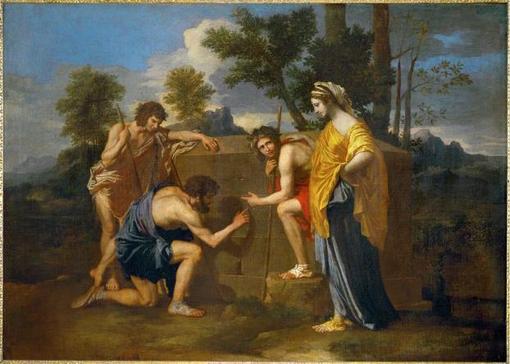
Figure 1. Nicolas Poussin, Et in Arcadia Ego, circa 1650, Oil on Canvas, (85 x 121 cm),
Paris, Musée du Louvre, CA 7300.

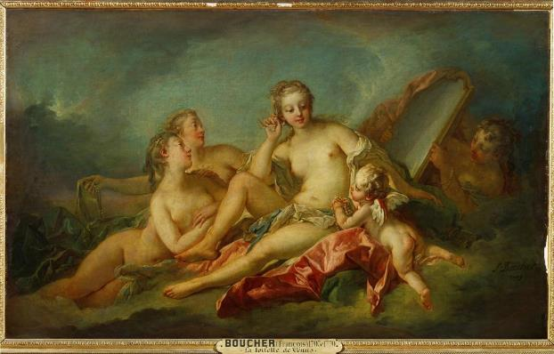

Figure 2. François Boucher, Toilette of Venus, 1749, Oil on Canvas (107 x 173 cm)
Paris, Musée du Louvre

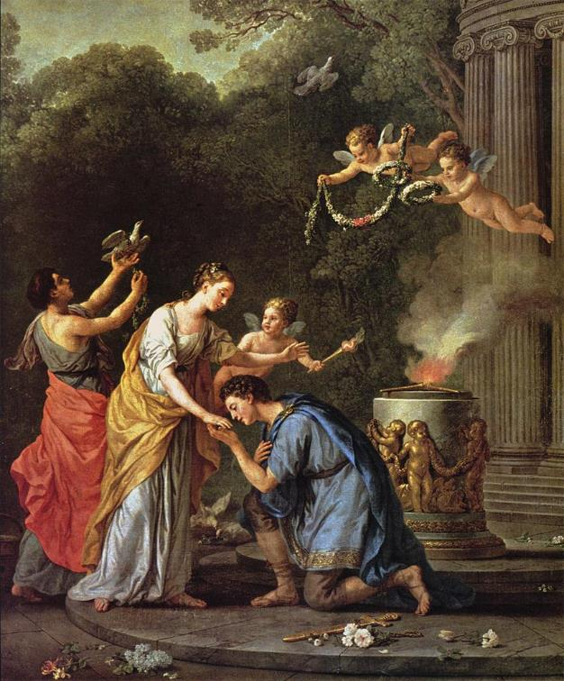

Figure 3. Joseph-MarieVien, Temple of Hymen, 1773, Oil on Canvas, (106 ½ x 89 inches)

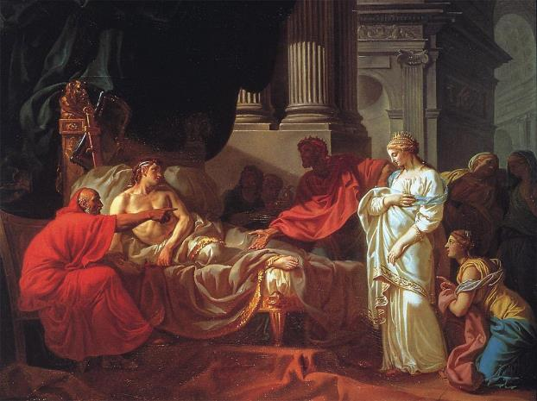

Figure 4. Jacques-Louis David, Antiochus and Stratonica, 1774, Oil on Canvas, (120 x 155 cm)

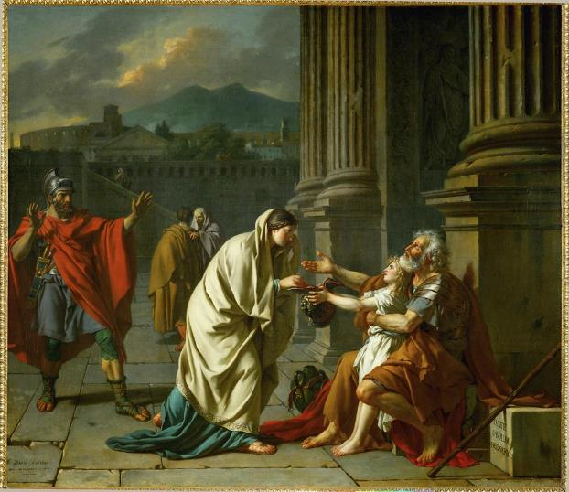

Figure 5. Jacques-Louis David, Belisarius Begging for Alms, 1781, Oil on Canvas (101 x 115 cm)
Paris, Musée du Louvre, CA 3694.

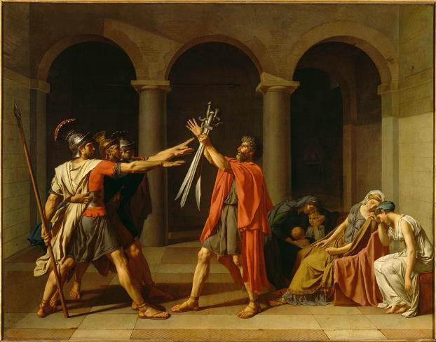

Figure 6. Jacques-Louis David, The Oath of the Horatii, 1784, Oil on Canvas, (330 x 425 cm)
Paris, Musée du Louvre CA 3692.

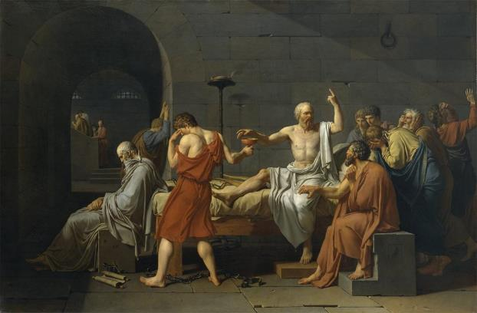

Figure 7. Jacques-Louis David, The Death of Socrates, 1787, Oil on Canvas, (129.5 x 196.2 cm)
New York, The Metropolitan Museum of Art

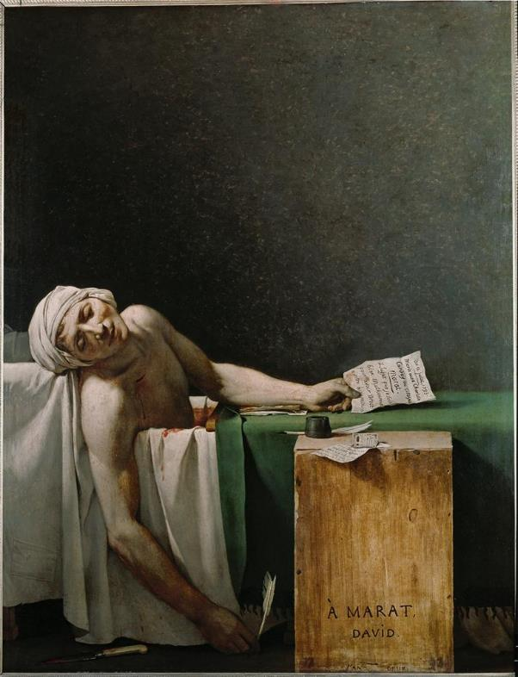

Figure 8. Jacques-Louis David, Death of Marat, 1793, Oil on Canvas, (165 x 128 cm)
Brussels, Musées Royaux des Beaux-Arts de Belgique CA 3261
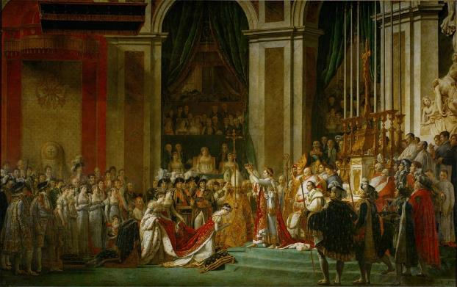

Figure 9. Jacques-Louis David, The Coronation of Napoleon and Josephine, 1807,
Oil on Canvas, (621 x 979 cm) Paris, Musée du Louvre CA 3699

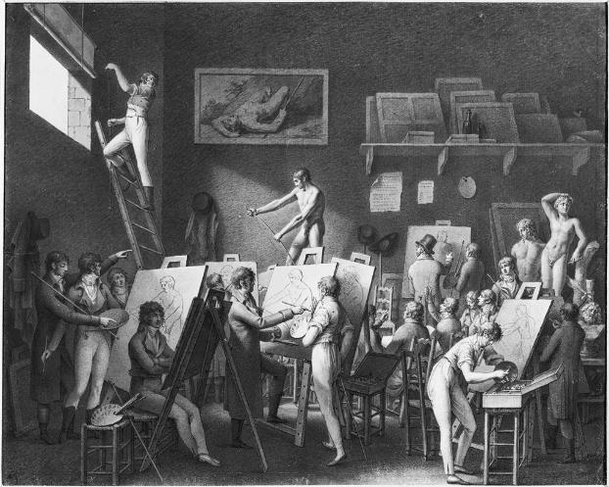

Figure 10. Jean-Henri Cless, The Studio of Jacques Louis David, c. 1810, Pen and Ink Wash,
(46 x 57 cm) Paris, Musée Carnavalet

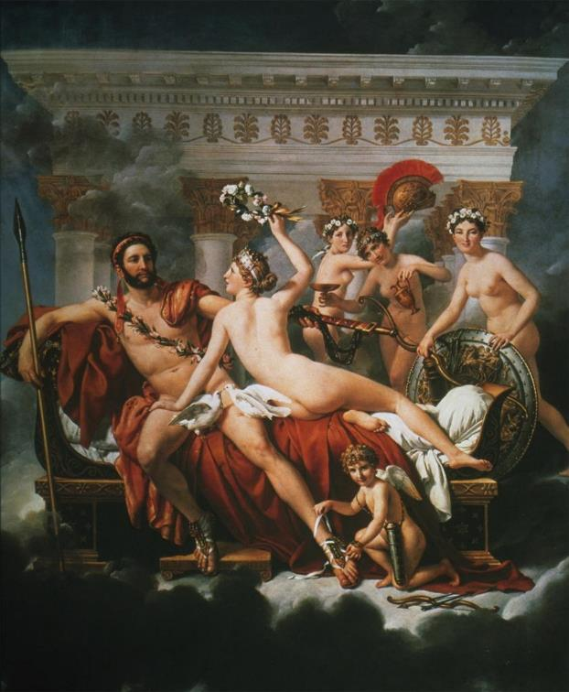

Figure 11. Jacques-Louis David, Mars Disarmed by Venus and Three Graces, 1824,
Oil on Canvas, (3.05 x 2.6 meters) Brussels, Musées Royaux des Beaux-Arts de Belgique

List of Illustrations

Figure 1. Poussin, Nicolas Poussin. Et in Arcadia Ego. 1650. Artstor, Accessed February 28, 2015. http://library.artstor.org/library/iv2.html?parent=true.

Figure 2. Boucher, François. Toilette of Venus. 1749. Artstor, Accessed February 28, 2015. http://library.artstor.org/library/iv2.html?parent=true.

Figure 3. Vien, Joseph-Marie. Temple of Hymen. 1773. Artstor, Accessed February 28, 2015. http://library.artstor.org/library/iv2.html?parent=true.

Figure 4. David, Jacques-Louis. Antiochus and Stratonica. 1774. Artstor, Accessed February 28, 2015. http://library.artstor.org/library/iv2.html?parent=true.

Figure 5. David, Jacques-Louis David. Belisarius Begging for Alms. 1781. Artstor, Accessed February 28, 2015. http://library.artstor.org/library/iv2.html?parent=true.

Figure 6. David, Jacques-Louis. The Oath of the Horatii. 1784. Artstor, Accessed February 28, 2015. http://library.artstor.org/library/iv2.html?parent=true.

Figure 7. David, Jacques-Louis. The Death of Socrates. 1787. Artstor, Accessed February 28, 2015. http://library.artstor.org/library/iv2.html?parent=true.

Figure 8. David, Jacques-Louis. Death of Marat. 1793. 1793. Artstor, Accessed February 28, 2015. http://library.artstor.org/library/iv2.html?parent=true.

Figure 9. David, Jacques-Louis. The Coronation of Napoleon and Josephine. 1807. Artstor, Accessed February 28, 2015. http://library.artstor.org/library/iv2.html?parent=true.

Figure 10. Cless, Jean-Henri. The Studio of Jacques Louis David. 1810. Artstor, Accessed February 28, 2015. http://library.artstor.org/library/iv2.html?parent=true.

Figure 11. David, Jacques-Louis. Mars Disarmed by Venus and Three Graces. 1824. Artstor, Accessed February 28, 2015. http://library.artstor.org/library/iv2.html?parent=true.

Bibliography

Adams, Laurie. The Methodologies of Art: An Introduction. 2nd ed. Boulder, CO: Westview Press, 2010.

"Autobiography of Jacques-Louis David" Exhibitions. The J. Paul Getty Museum, Accessed January 30, 2015. http://www.getty.edu/art/exhibitions/david/extra_autobiography.html.

Bohnen, Blythe. "Old Masters: New Apprentices." The Metropolitan Museum of Art Bulletin 27, no. 4 (1968): 230-236.

Boime, Albert. Art in an Age of Revolution, 1750-1800. A Social History of Modern Art. Vol. 1. Chicago: University of Chicago Press, 1987.

Bordes, Philippe, Jacques Louis David, Sterling and Francine Clark Art Institute, and J. Paul Getty Museum. Jacques-Louis David: Empire to Exile. New Haven: Yale University Press, 2005.

Brookner, Anita. Jacques-Louis David, A Personal Interpretation. Aspects of Art Lecture; 1974. London: Published for the British Academy by Oxford University Press, 1975.

———. Jacques-Louis David. Icon Editions. 1 U.S. Ed. New York: Harper & Row, 1980.

Burroughs, Bryson. "A Picture by Jacques Louis David." The Metropolitan Museum of Art Bulletin 26, no. 6 (1931): 140-144.

Cailleux, Jean. "Aspects of Neo-Classicism in France." The Burlington Magazine 115, no. 840 (1973): i-xii.

Carrier, David. "The Political Art of Jacques-Louis David and His Modern-Day American Successors." Art History 26, no. 5 (2003): 730-751.

Caso, Jacques de. "Jacques-Louis David and the Style 'all' Antica'." The Burlington Magazine 114, no. 835 (1972): 686-690.

Charlot, Jean. "Art, Quick or Slow." The American Magazine of Art 27, no. 11 (1934): 571-576.

Clifton-Mogg, Caroline. The Neoclassical Sourcebook. London: Cassell, 1991.

Cooper, Douglas. "Jacques-Louis David: A Bi-Centenary Exhibition." The Burlington Magazine 90, no. 547 (1948): 276-280.

David, Jacques Louis and Dorothy Johnson. Jacques-Louis David: New Perspectives. Studies in Seventeenth- and Eighteenth-Century Art and Culture. Newark, DE: University of Delaware Press, 2006.

David, Jacques Louis, and Richard Cantinelli. Jacques-Louis David, 1748-1825. Paris; Bruxelles: Les Éditions G. van Oest, 1930.

de Nanteuil, Luc. Jacques-Louis David. Library of Great Painters. New York: Abrams, 1985.

———. Jacques-Louis David. [Masters of Art Series]. New York: H.N. Abrams, 1990.

Pageant-Master of the Republic, Jacques-Louis David and the French Revolution. Directed by David Lloyd Dowd. 1948. Lincoln: University of Nebraska Press, Film.

Dowley, Francis H. "An Exchange on Jacques Louis David's." Art Bulletin 70, no. 3 (1988): 504.

Ettlinger, L. D. "Jacques Louis David and Roman Virtue." Journal of the Royal Society of Arts 115, no. 5126 (1967): 105-123.

Francis, Henry S. "A Portrait by Jacques Louis David." The Bulletin of the Cleveland Museum of Art 32, no. 6, Part I (1945): 83-85.

———. "Jacques Louis David: Cupid and Psyche." The Bulletin of the Cleveland Museum of Art 50, no. 2 (1963): 29-34.

Galitz, Kathryn C. "The Legacy of Jacques Louis David (1748–1825)" Heilbrunn Timeline of Art History. The Metropolitan Museum of Art, Accessed January 29, 2015. http://www.metmuseum.org/toah/hd/jldv/hd_jldv.htm.

Gambino, Megan. "Bethany Hughes on Socrates" History. Smithsonian Institute, Accessed January 30, 2015.
http://www.smithsonianmag.com/history/bettany-hughes-on-socrates-802862/.

Gontar, Cybele. "Neoclassicism" Heilbrunn Timeline of Art History. The Metropolitan Museum of Art, Accessed January 20, 2015. http://www.metmuseum.org/toah/hd/neoc_1/hd_neoc_1.htm.

Guardini, Romano, and Basil Wrighton. The Death of Socrates. New York: Sheed & Ward, 1948.

Hauptman, William. "'The Blood-Stained Brush': David and the British circa 1802." The British Art Journal 10, no. 3 (2009): 78-97.

Hemingway, Colette, and Seán Hemingway. "The Art of Classical Greece (ca. 480–323 B.C.)" Heilbrunn Timeline of Art History. The Metropolitan Museum of Art, Accessed January 20, 2015. http://www.metmuseum.org/toah/hd/tacg/hd_tacg.htm.

Honour, Hugh. Neo-Classicism. Pelican Book A978. Harmondsworth, UK: Penguin, 1968.
Hughes, Bettany. The Hemlock Cup: Socrates, Athens and the Search for the Good Life. New York: A.A. Knopf, 2011.

Irwin, David G. Neoclassicism. Art & Ideas. London: Phaidon, 1997.
Johnson, Dorothy. Jacques-Louis David: Art in Metamorphosis. Princeton Series in Nineteenth-Century Art, Culture, and Society. Princeton, NJ: Princeton University Press, 1993.

Jones, Stephen. The Eighteenth Century. Cambridge Introduction to the History of Art. Vol. 5. Cambridge Cambridgeshire; New York: Cambridge University Press, 1985.

"Jacques-Louis David" Artists. The J. Paul Getty Museum, Accessed January 20, 2015. http://www.getty.edu/art/gettyguide/artMakerDetails?maker=544.

"Jacques-Louis David" Biography.Com. A&E Television Networks, Accessed January 20, 2015. http://www.biography.com/people/jacques-louis-david-9267043.

"Jacques-Louis David" Collection. The J. Paul Getty Museum, Accessed January 20, 2015. http://www.getty.edu/art/collection/artists/538/jacques-louis-david-french-1748-1825/.

"Jacques-Louis David (1748-1825)" Neo-Classicism and the French Revolution. The Trustees of Boston College, Accessed January 21, 2015. http://www.bc.edu/bc_org/avp/cas/his/CoreArt/art/neocl_dav.html.

"Jacques-Louis David: The Death of Socrates" Neo-Classicism and the French Revolution. The Trustees of Boston College, Accessed January 20, 2015. http://www.bc.edu/bc_org/avp/cas/his/CoreArt/art/neocl_dav_soc.html.

"Jacques Louis David: The Death of Socrates (31.45)". Heilbrunn Timeline of Art History. The Metropolitan Museum of Art, Accessed January 20, 2015. http://www.metmuseum.org/toah/works-of-art/31.45.

"Jacques-Louis David: Empire to Exile" Exhibitions. The J. Paul Getty Museum, Accessed January 20, 2015. http://www.getty.edu/art/exhibitions/david/overview.html.

Kelder, Diane. Aspects of "Official" Painting and Philosophic Art, 1789- 1799. Outstanding Dissertations in the Fine Arts. New York: Garland Pub., 1976.

Korshak, Yvonne. "Paris and Helen by Jacques Louis David: Choice and Judgment on the Eve of the French Revolution." The Art Bulletin 69, no. 1 (1987): 102-116.

Ledbury, Mark. "Unpublished Letters to Jacques-Louis David from His Pupils in Italy." The Burlington Magazine 142, no. 1166 (2000): 296-300.

———. "Visions of Tragedy: Jean-François Ducis and Jacques-Louis David." Eighteenth-Century Studies 37, no. 4 (2004): 553-580.

Lee, Virginia. "Jacques-Louis David: The Versailles Sketchbook-I." The Burlington Magazine 111, no. 793 (1969): 197-208.

———. "Jacques-Louis David: The Versailles Sketchbook - II." The Burlington Magazine 111, no. 795 (1969): 360-367+369.

Lee, Simon. David. Art & Ideas. London: Phaidon, 1999.

Leoussi, Athena S. Nationalism and Classicism: The Classical Body as National Symbol in Nineteenth-Century England and France. Houndmills, Basingstoke, Hampshire; New York: St. Martin's Press, 1998.

Lightfoot, Christopher. "The Roman Empire (27 B.C.–393 A.D.)" Heilbrunn Timeline of Art History. The Metropolitan Museum of Art, Accessed January 29, 2015. http://www.metmuseum.org/toah/hd/roem/hd_roem.htm.

MacColl, D.S. "Jacques-Louis David and the Ducreux Family." The Burlington Magazine for Connoisseurs 72, no. 423 (1938): 263-265+268-270.

The Passing Show. 25. Directed by Leslie Megahey, Home Vision, RM Arts, and British Broadcasting Corporation. 1984. Chicago: Home Vision Distributor, 1986. Film

Monneret, Sophie, and Jacques Louis David. David and Neo-Classicism [David et le Néoclassicisme. English.]. Paris: Terrail, 1999.

"Neoclassicism in Seventeenth- and Eighteenth-Century European Art" Heilbrunn Timeline of Art History. The Metropolitan Museum of Art, Accessed January 29, 2015. http://www.metmuseum.org/toah/hi/hi_1718neoclas.htm.

Paulson, Ronald. Representations of Revolution, 1789-1820. New Haven: Yale University Press, 1983.

Philp, Mark, "Thomas Paine" The Stanford Encyclopedia of Philosophy. Stanford University, Accessed February 15, 2015. http://www.plato.stanford.edu/archives/win2013/entries/paine

The Power of Art: David. Directed by Films Media Group. BBC, 2006.

Preston, Stuart. "New York." The Burlington Magazine 104, no. 708 (1962): 132-134.

Roberts, Warren. Jacques-Louis David, Revolutionary Artist: Art, Politics, and the French Revolution. Chapel Hill: University of North Carolina Press, 1989.

———. Jacques-Louis David and Jean-Louis Prieur, Revolutionary Artists: The Public, the Populace, and Images of the French Revolution. Albany, NY: State University of New York Press, 2000.

Rosenberg, P. "Jaques-Louis David: Death of Patroclus" Catalogue Raisonné Des Dessins. Musée du Louvre, Accessed January 20, 2015.
http://www.louvre.fr/en/oeuvre-notices/funeral-patroclus.

Schnapper, Antoine. "Jacques-Louis David 1748-1825" Catalogue d'Exposition. Musée du Louvre, Accessed January 22, 2015.
http://www.louvre.fr/en/oeuvre-notices/oath-horatii.

Schnapper, Antoine. David. New York, NY: Alpine Fine Arts Collection, 1980.

Simon, Robert. "David's Martyr-Portrait of Le Peletier De Saint-Fargeau and the Conundrums of Revolutionary Representation." Art History 14, no. 4 (1991): 459.

Sérullaz, Arlette, and Virginia Spate, Art Gallery of New South Wales, and National Gallery of Victoria. French Painting: The Revolutionary Decades, 1760-1830. Sydney: Australian Gallery Directors Council, 1980.

A Classical Frieze by Jacques Louis David: Sacrifice of the Hero: The Roman Years. Directed by Seymour Howard and Jacques Louis David. 1975. Sacramento, CA: E.B. Crocker Art Gallery, Film.

Shennan, Andrew. The Fall of France, 1940. Turning Points. Harlow, England; New York: Longman, 2000.

Sorabella, Jean. "The Grand Tour" Heilbrunn Timeline of Art History. The Metropolitan Museum of Art, Accessed January 29, 2015. http://www.metmuseum.org/toah/hd/grtr/hd_grtr.htm.

Steves, Rick. "A New Look for an Old City". Smithsonian Institute, Accessed January 30, 2015. http://www.smithsonianmag.com/ricksteves/a-new-look-for-an-old-city-20561617/.

Vidal, Mary. "David among the Moderns: Art, Science, and the Lavoisiers." Journal of the History of Ideas 56, no. 4 (1995): 595.

"Who Was Jacques-Louis David?" Exhibitions. The J. Paul Getty Museum, Accessed January 30, 2015. http://www.getty.edu/art/exhibitions/david/extra_david.html.

Wilson, Elizabeth B. "Jacques-Louis David" History. Smithsonian Institute, Accessed January 21, 2015. http://www.smithsonianmag.com/history/jacques-louis-david-60191520/?no-ist.

Wilson, Emily R. The Death of Socrates: Hero, Villain, Chatterbox, Saint. Profiles in History. London: Profile, 2007.

Wolfsdorf, David. "The Irony of Socrates." The Journal of Aesthetics and Art Criticism 65, no. 2 (2007): 175-187.

Laurie Schneider Adams, The Methodologies of Art (Boulder: Westview Press, 2010), 30.
Antoine Schnapper, David (New York: Alpine Fine Arts Collection, 1980), 11.
Schnapper, 18.
Andrew Shennan, The Fall of France, 1940 (New York: Longman, 2000), 45.
Luc de Nanteuil, Jacques-Louis David (New York: Abrams, 1985), 7.
de Nanteuil, 9.
"Autobiography of Jacques-Louis David," The J. Paul Getty Museum, Accessed January 30, 2015. http://www.getty.edu/art/exhibitions/david/extra_autobiography.html.
Schnapper, 14.
Schnapper, 29.
Shennan, 64.
de Nanteuil, 16.
Schnapper, 47.
Shennan, 71.
Mark Philp, "Thomas Paine" The Stanford Encyclopedia of Philosophy, Accessed February 15, 2015. http://www.plato.stanford.edu/archives/win2013/entries/paine.
Schnapper, 81.
Bettany Huges, The Hemlock Cup (New York: Knopf, 2011), 115.
Shennan, 84.
Warren Roberts, Jacques-Louis David, Revolutionary Artist: Art, Politics, and the French Revolution (Chapel Hill: University of North Carolina Press, 1989), 227
Roberts, 195.
de Nanteuil, 28.
"Jacques-Louis David: Empire to Exile," The J. Paul Getty Museum, Accessed January 20, 2015. http://www.getty.edu/art/exhibitions/david/overview.html.
de Nanteuil, 31.
de Nanteuil, 38.
de Nanteuil, 41.
de Nanteuil, 43.

