Cultural Community Heritage: An Executive Summary
The Business of Art

Art Center of Citrus County
2644 N Annapolis Avenue
Hernando, FL 34442

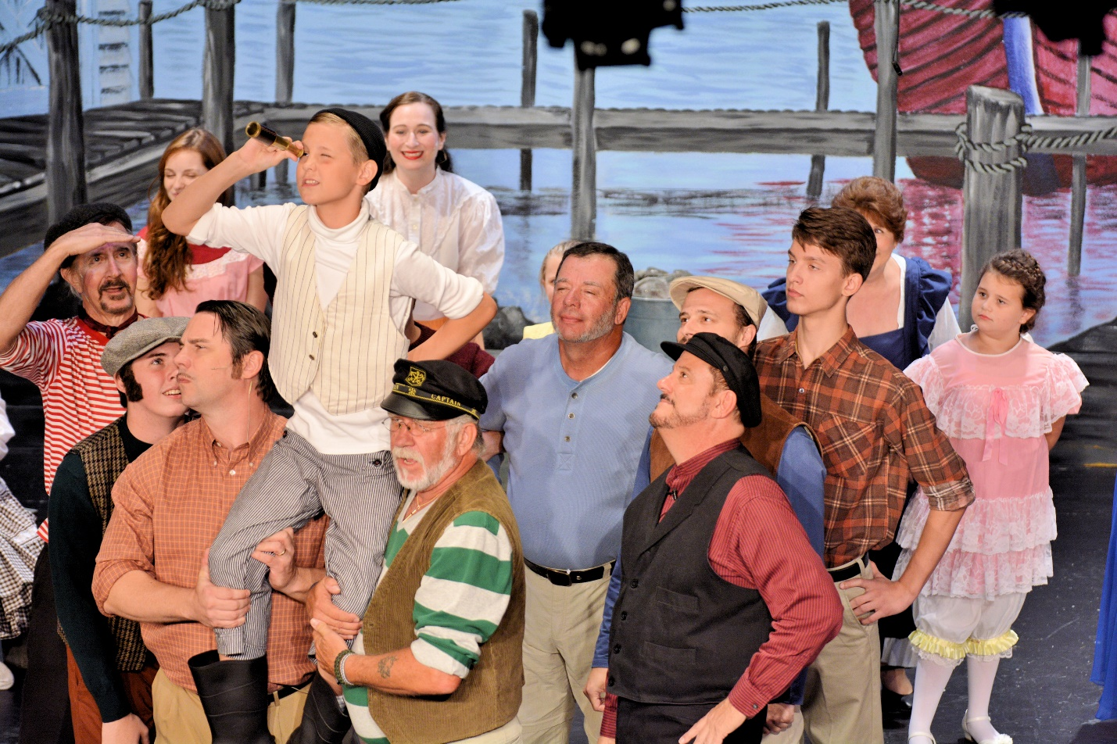
Figure 1.“Blow High, Blow Low” performed by the ACCC cast of Carousel, by Mac Harris

Jennifer McAninch
February 2, 2017
Cultural Community Heritage: An Executive Summary
The Business of Art
Art Center of Citrus County

The Art Center of Citrus County is a 501c3 not-for-profit corporation whose purpose is to encourage and promote art in all its forms to the citizens of Citrus County. The Art Center is owned and operated by its members and is managed by a seven member volunteer executive board elected annually by a vote of the membership (Art Center of Citrus County [ACCC], 2011, p. 1).
Contact Information
The Art Center of Citrus County, located at 2644 N Annapolis Avenue, Hernando, Florida, serves a largely rural population near the central coast. The Art and Education Center operates on a schedule which fluctuates seasonally according to special events. The box office is open from 1pm to 4pm daily, Monday through Friday. There are several avenues through which contact can be made. To reach the organization office, call 352.746.0924. The box office can be contacted at 352.746.7606. The organization website, artcenterofcitruscounty.org, also provides access to various electronic forms.
Background Information
The original organization name was the Citrus County Art League. In early years, the group functioned largely as an art appreciation group, with a few practicing local artists. Members were predominantly retirees who had relocated to several adult-living communities in the surrounding area. Funding for the purchase of land and initial building construction was achieved through small personal loans from multiple league members. These loans were repaid randomly, on an annual basis, by selecting a name from a hat. The original building, completed in 1984, was known as the Art and Education Building. The league continued operating in this informal structure until 1998. Growing membership and program demands forced a shift and the organizational structure began to evolve. The league commissioned blueprints for a community theater, but had no financial plan in place to fund the building.
Sharon Harris was brought on as Vice President of programs in 1998 and began a wholescale restructuring of the organization using an established nonprofit business model. An entrepreneur and artist herself, Harris had a unique understanding of both the creative and financial duties impressed upon the Art League. She established an official operating budget, recruited local business leaders to sit on a financial advisory committee, and formalized the organization as a 501c3 nonprofit corporation. Soon after the reorganization, Harris began a feasibility study with a goal of completing the much desired community theater. Under her leadership, the Art League amassed more than $300,000 in reserves. Armed with a new structure, a financially feasible goal, and substantial reserves, Harris wrote a grant proposal and applied for matching funds from the State of Florida. Through dedicated fundraising efforts, the reserves grew to $500,000. Matched by the state grant, the theater was funded in full. The structure was completed in 2003.
Business Operations
The organization known as the Citrus County Art League is now registered to do business as The Art Center of Citrus County, a moniker considered more descriptive of its multiple services. A five year business plan guides the Art Center and provides structure. The organization has truly become a corporation, with a successful business model and solid financial planning. In 2010, Mac Harris, husband to Sharon, was elected President. He continues to guide the Art Center in hopes of sustaining and expanding the program. The Executive Director, responsible for managing the administrative office and box office, holds the only paid position within the corporation. Members of the Board of Directors feel that absolute transparency is a key component in their continued success. All corporate documents, including budget and financial projections are available to interested parties upon request.
The current Board of Directors is organized as follows:
Mac Harris, President
Ed Martin, Vice President of Performing Arts
Jim Houle, Vice President of Visual Arts
Julian Weingarten, Assistant V.P. of Performing Arts
Geri Schwenkler, Assistant V.P. of Visual Arts
Carl Vykowski, Vice President of Marketing
Don Taylor, Treasurer
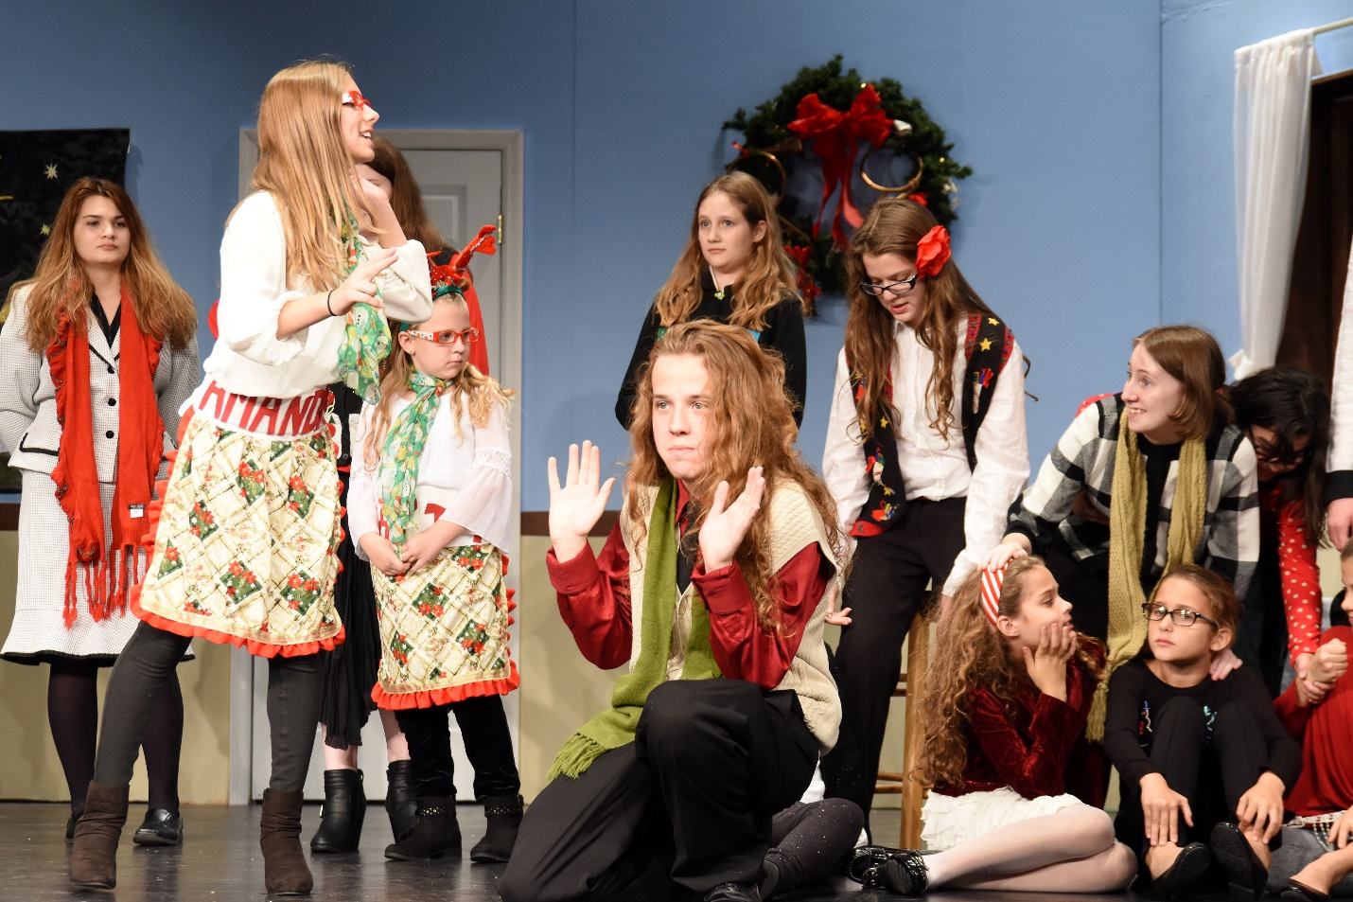
Figure 2. Youth Theater Program Production, Winter 2016, Mac Harris
Performing Arts Program
The performing arts program has been very successful. It currently generates up to seventy-five percent of all annual income. Proceeds generated from seasonal theater subscriptions alone represents a significant portion of the operating budget. The theater season begins each year in spring. Over the course of the year the theater will produce five plays and two musicals. Summer educational programs include Children’s Theater and the Youth Academy. Community youth outreach draws students from around the county to participate in theater programing. A play selection committee creates a proposal of production with an emphasis on variety and audience interest. This proposal is reviewed and officially accepted by the Board of Directors.
Visual Arts Program
The visual arts program, housed in the expanded Art and Education building provides gallery space for local artists to hang their work. The gallery space also hosts annual juried competitions for artists who work in various media. Classes in painting, photography and digital arts are offered along with specialty showcases presented by visiting artists. The largest membership within the visual arts program is held by the Camera Club, which currently has approximately one hundred members. Each month, photographers submit images which follow given themes such as still life, landscape, motion, and high contrast black and white. The current exhibition in the gallery is a series of textile arts, predominantly quilting.
Current Challenges
With the exception of the Executive Director, all Art Center positions are filled by a network of volunteers. As the organization continues to expand, the volunteer base must also grow. Recruitment challenges are a primary concern. Other issues associated with a developing program and aging infrastructure are also under consideration. Challenges with the available physical space at the Art Center make scheduling multiple programs difficult. A recent status review also noted the absence of backup systems for technical equipment in the theater. These issues will be addressed during the upcoming formation of the five-year business plan.
Future Plans
Plans for programing at the Art Center of Citrus County include expansion of services in both the performing arts and visual arts. The theater will seek to produce staged readings and other “front of the curtain” events that occur concurrent to the established performance season. Education and operational training will be arranged for the volunteer workforce, which includes directors, stage managers, lighting and sound technicians. The visual arts program will seek to incorporate traveling exhibitions and demonstrations in conjunction with the Appleton Museum and other regional galleries. Additional funding will be allotted for lectures and presentations by nationally recognized artists. Youth programming will also be expanded to include an educational summer program in visual arts.
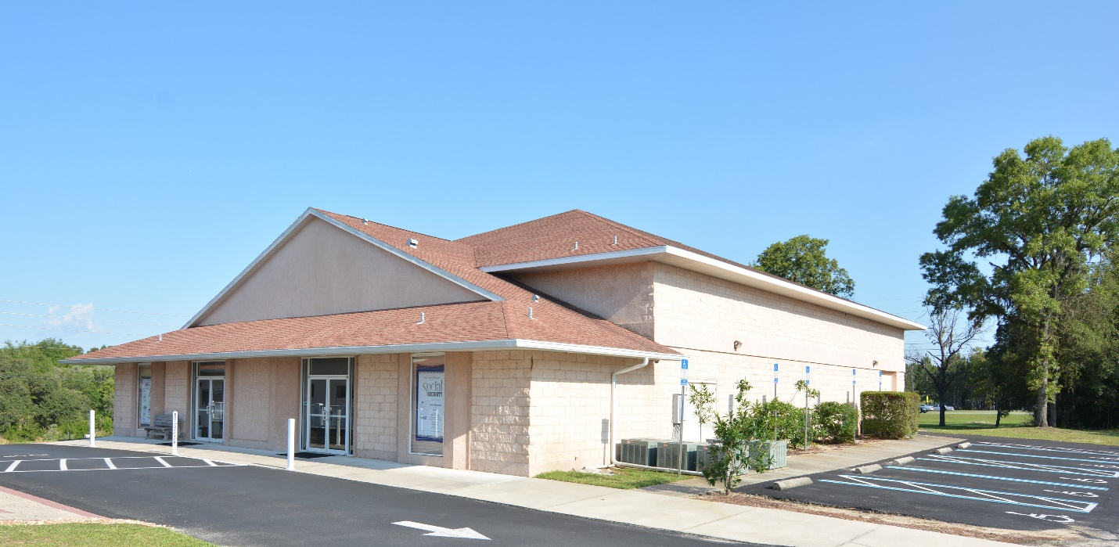
Figure 3. Performing Arts Center, Mac Harris
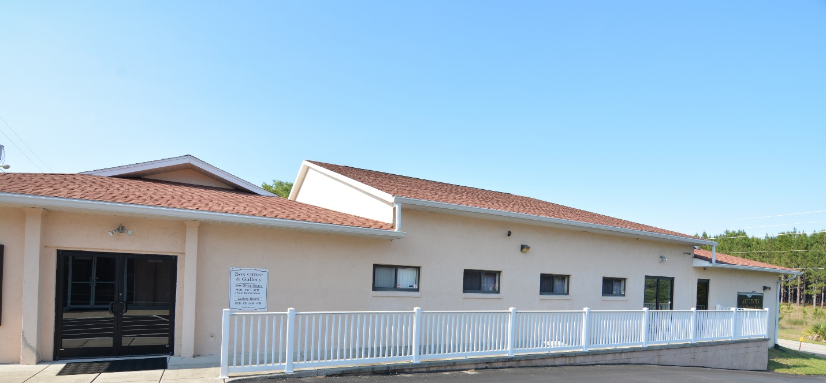
Figure 4. Visual Art and Education Center, Mac Harris
Figure 5. Interior Meeting and Gallery Space, Mac Harris

References

Art Center of Citrus County. (2011). Business Plan 2011 - 2016.
Harris, M. (2017, February 2). President - Art Center of Citrus County. (J. McAninch, Interviewer) Hernando, FL.
Harris, M. (n.d.). Assorted Photographs. Art Center of Citrus County.

Author’s Note
Much of the information contained in this executive summary was derived from a personal interview with Mac Harris. Mr. Harris was generous with his time and had a wealth of information regarding the history and operation of the Art Center of Citrus County. He also graciously provided some of the images contained within the body of this document.
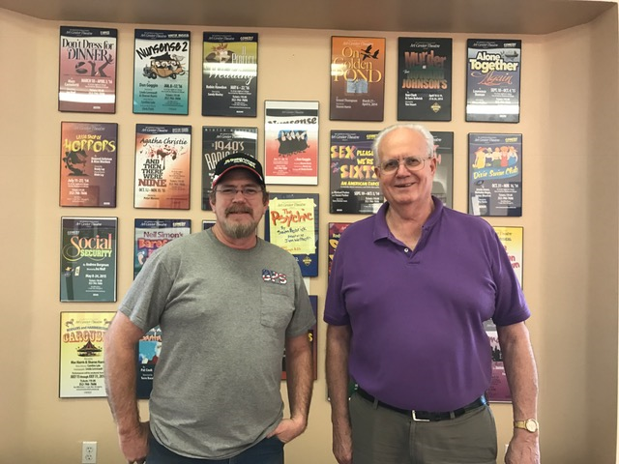
Figure 6. Mac Harris (on right) with technician, Jennifer McAninch, 2017
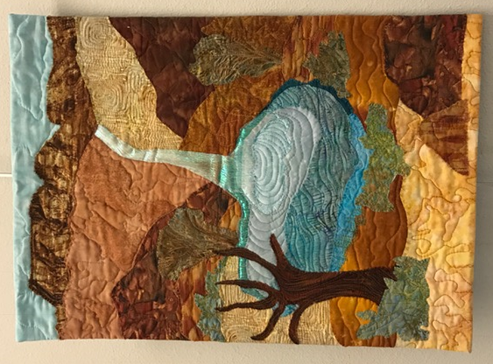 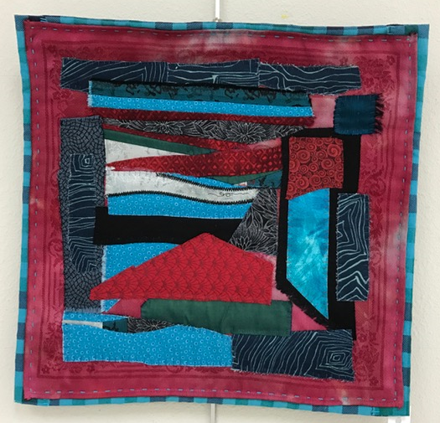 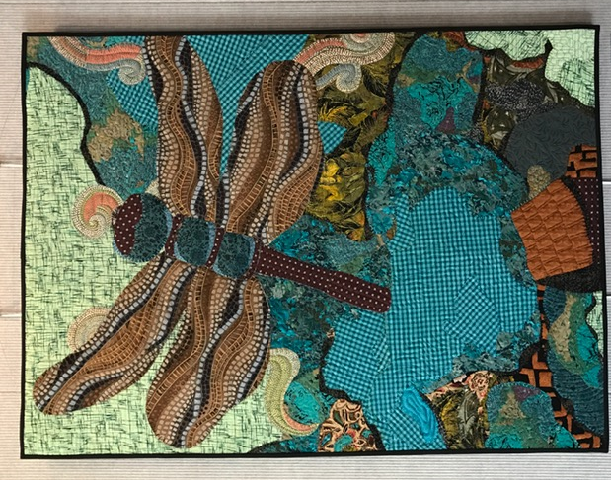
Figure 7. Images from the Current Textile Arts Contest, Jennifer McAninch

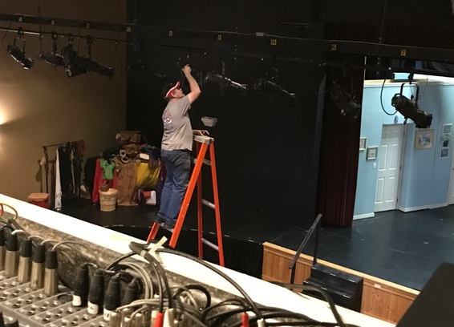
Figure 10. Changing the Bulb on #24, Jennifer McAninch, 2017

