John Singer Sargent
Madame X, 1884

Jennifer McAninch
Arizona State University

ARS 340 Art in America
April 27, 2015
At the end of the Nineteenth Century, artists were developing a myriad of responses to the restrictions set by the European academic system. Impressionists denied entrance into the annual Salon began to organize private exhibitions. The development of photography further challenged traditional definitions of art and aesthetics. Despite these alternative approaches, the most direct path to artistic success was through the academies, the most prestigious of which thrived in the heart of Paris. Of those artists that chose to compete for placement in the Salon, few caused such a stir as a young American painter named John Singer Sargent. His chosen subject matter, portraiture of upper class individuals, was long established. In style and approach, however, Sargent began to offer a fresh perspective. At the pinnacle of his popularity in France, he submitted a painting that would fly in the face of convention, incite vicious attacks from critics and ultimately cause Sargent to leave Paris altogether. The painting was exhibited in the Salon of 1884 under the title Portrait de Mme ***, in later years it would become known as The Portrait of Madam X.
John Singer Sargent was born in Florence in 1856 to American parents, Fitzwilliam Sargent and Mary Singer, who led an expatriate existence as they traveled throughout Europe. The family’s lifestyle made a customary education impossible and his parents became Sargent’s tutors: “He studied geography, arithmetic, reading, and other disciplines under his father's tutelage... His mother, an amateur artist, encouraged him to draw, and her wanderlust furnished him with subjects.” Even as a child, Sargent was exposed to the great accumulation of art in museums and private collections throughout Europe. In 1874, when Sargent was eighteen, the family relocated to Paris to allow him to pursue his goal of becoming a professional artist. It was in the studio of Carolus-Duran that John Singer Sargent would receive formal artistic training. The method encouraged in the studio was to reject preparatory drawing and move directly to the application of paint to canvas. Carolus-Duran celebrated the influence of Rembrandt, Frans Hals, and most especially Diego Velázquez. The expressive nature of this painting style enhanced the subject matter and often imbued figures with a sense of action and emotion that was absent from paintings done with a more restrained, polished approach.
Sargent began submitting works to the Paris Salon in 1877. Though he did not limit himself strictly to portraiture, it was in this genre that the young artist found his most immediate success. He began to receive multiple commissions for portraits, many from fellow expatriate Americans who had made Paris their home. Sargent often placed his figures against simplified, slightly abstracted backgrounds. Though he was criticized for rejecting conventional compositional arrangement, as exemplified in his portrayal of The Daughters of Edward Darley Boit, (1882), he was steadily building a reputation as an exceptional talent. It was in the interest of further establishing himself that Sargent began to contemplate a new challenge. The celebrated American beauty, Virginie Avegno, wife of Parisian banker Pierre Gautreau, drew Sargent as no other subject had. He began to seek permission to paint her and after multiple inquiries, the lady finally agreed. In the summer of 1883, the painting began. The artist struggled with almost every aspect of the work. He arranged and rearranged position of both figure and attire, ultimately settling on a depiction that was both unusual and visually stunning.
Madame Gautreau stands facing forward with her head turned to the left in full profile. The arrangement of her hair, expertly twisted to prohibit its escape, delicately frames her face. Her elegant features are a cool contrast to the warm, empty background. She shares the picture plane with a single object, a highly polished table, also depicted in warm brown. Her tightly corseted black dress lengthens her voluptuous figure and draws attention to the lovely expanse of flesh above the neckline. In her left hand she clasps the folds of her gown, causing the light to catch and reflect on the rich satin. The tone of her skin is perhaps the most unusual aspect of the painting. Instead of warm, fleshy peaches and pinks, the artist uses cool blues, purples and stark white to separate the figure from the space that surrounds it. Upon its installation in the 1884 Salon, the painting received bitter criticism. Detractors argued that the cool flesh was more suited to a corpse than to the acclaimed beauty. The décolletage and drooping dress strap were attacked as indecent and improper. Shocked and unprepared for the scathing reception, the artist soon left Paris for London.
John Singer Sargent continued to paint, reestablished and eventually surpassed his early popularity. He painted men, women and children, as well as U.S. Presidents and stage performers. His prolific career would encompass portraiture, landscape and genre scenes. He worked in watercolors as adroitly as in oils, in open air as comfortably as in studio. Throughout those years, he kept the portrait of Madame Gautreau nearby. It was not until after her death in 1915 that he conceded to part with it: “When, eventually, he sold it to the Metropolitan, he commented, ‘I suppose it is the best thing I have done,’ but asked that the Museum disguise the sitter’s name.”
Bibliography
Corsano, Karen, Daniel Williman, and Richard Ormond. John Singer Sargent and His Muse. Lanham, MD: Rowman & Littlefield, 2014.
Fairbrother, Trevor J., John Singer Sargent, and Seattle Art Museum. John Singer Sargent:The Sensualist. Seattle, WA: Seattle Art Museum, 2000.
Fairbrother, Trevor. ""Man Screaming" by John Singer Sargent." American Art 15, no. 1 (2001): 84-89.
Fairbrother, Trevor J. "Notes on John Singer Sargent in New York, 1888-1890." Archives of American Art Journal 22, no. 4 (1982): 27-32.
"John Singer Sargent." The American Magazine of Art 16, no. 6 (1925): 285-287.
"John Singer Sargent: Madame X (Madame Pierre Gautreau)." Heilbrunn Timeline of Art History. The Metropolitan Museum of Art, Accessed April 13, 2015. http://www.metmuseum.org/toah/works-of-art/16.53.
"Madame X (Madame Pierre Gautreau)" The Collection Online. The Metropolitan Museum of Art, Accessed April 13, 2015.
http://www.metmuseum.org/collection/the-collection-online/search/12127
Mahon, Dorothy and Silvia Centeno. "A Technical Study of John Singer Sargent's Portrait of Madame Pierre Gautreau." Metropolitan Museum Journal 40, Essays in Memory of John M. Brealey (2005): 121-129, 14-15.
McCaughey, Patrick. "Native and Nomad: Winslow Homer and John Singer Sargent." Daedalus 116, no. 1, Philanthropy, Patronage, Politics (1987): 133-153.
Moss, Dorothy. "John Singer Sargent, 'Madame X' and 'Baby Millbank'." The Burlington Magazine 143, no. 1178 (2001): 268-275.
Shone, Richard. "John Singer Sargent and the Edwardian Age." The Burlington Magazine 121, no. 917 (1979): 532-536.
Sargent, John Singer, Elaine Kilmurray, Richard Ormond, Mary Crawford Volk, Tate Gallery, National Gallery of Art, and Museum of Fine Arts, Boston. John Singer Sargent. Princeton, NJ: Princeton University Press, 1998.
Weinberg, H. Barbara. "John Singer Sargent (1856–1925)." Heilbrunn Timeline of Art History. The Metropolitan Museum of Art, Accessed April 13, 2015. http://www.metmuseum.org/toah/hd/sarg/hd_sarg.htm
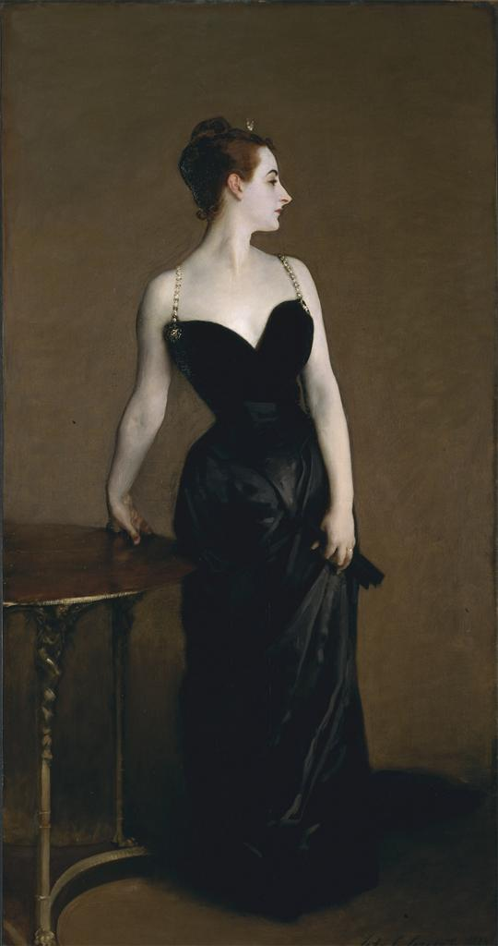
John Singer Sargent, Madame X (Madame Pierre Gautreau), 1884, Oil on Canvas,
208.6 cm x 109.9 cm, Metropolitan Museum of Art, New York, NY
Image accessed through ArtStor.org

Barbara H. Weinberg, "John Singer Sargent (1856–1925)." Heilbrunn Timeline of Art History. The Metropolitan Museum of Art, Accessed April 13, 2015. http://www.metmuseum.org/toah/hd/sarg/hd_sarg.htm
"John Singer Sargent: Madame X (Madame Pierre Gautreau)" Heilbrunn Timeline of Art History. The Metropolitan Museum of Art, Accessed April 13, 2015. http://www.metmuseum.org/toah/works-of-art/16.53.
"Madame X (Madame Pierre Gautreau)" The Collection Online. The Metropolitan Museum of Art, Accessed April 13, 2015. http://www.metmuseum.org/collection/the-collection-online/search/12127

