Comparison of Two Paintings by John Singleton Copley

Jennifer McAninch
Arizona State University

ARS 340 Art in America
March 30, 2015

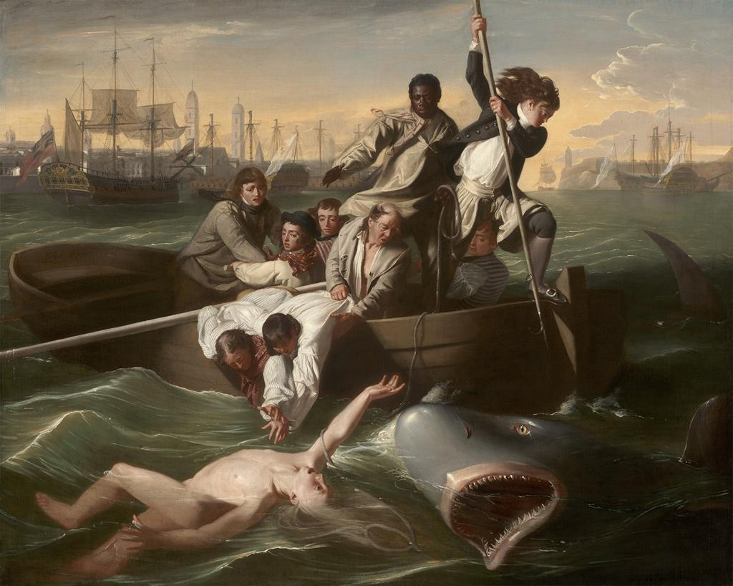
John Singleton Copley, Watson and the Shark, 1778, Oil on Canvas,
182 cm x 230 cm, Museum of Fine Arts, Boston Massachusetts
Image accessed through ArtStor.org
Among Colonial American painters, John Singleton Copley stands out as one of the most prodigious and successful. His work in America, mostly Boston and New York, includes many portraits of successful upper echelon citizens and their families. Though he received minimal training, Copley created remarkable likenesses of his subjects. He surrounded the figures with signifiers of both their position and their character. As the political turmoil of a building revolution increased, Copley relocated his family to England. His exposure to the European art world and the influence of the British Academy was reflected in much of his later work. History painting, an uninspiring genre to colonial patrons, gained new precedence for Copley and represented a significant portion of his English oeuvre. A comparison of his paintings, Daniel Crommelin Verplanck, (1771) and Watson and the Shark, (1778), illustrates the evolution of the artist and his style.
Prominent citizens in Colonial America had a desire to project an image of success and a preference for the British portrait style. John Singleton Copley became a resounding success by serving both aspects. An example of his mature portrait style can be seen in the painting, Daniel Crommelin Verplanck, (1771). In the center of the painting, a young boy gazes out as he plays with a pet squirrel. He sits on a stone pedestal and is presented in three quarter profile. The area surrounding the figure is a combination of architectural and natural elements which are kept dark and muted, with low values and earth tones. The boy has light skin and bright clothing, stark contrasts to the deep brown of the pillar which frames his features. The whole scene is contrived to draw attention to the boy and announce his importance. The artist’s meticulous attention to detail is evident in the execution of the figure. From the white ruffles on the boy’s cuffs, to the glint of brass on his shoe buckles, the luxury of his privileged childhood is apparent. Copley further exercises his considerable skills in the depiction of the boy’s pet. Each strand of fur is carefully rendered and appears soft enough to beckon a stroke. Texturally rich and dramatically lighted, this portrait serves the patron as a declaration of prestige and the artist as a confirmation of technical mastery.
In his move to England, John Singleton Copley altered his perception, technique and objective. The artist was influenced by members of the British Academy including the director, Sir Joshua Reynolds. The result was an artistic style which shares few commonalities with that employed in the Verplanck portrait. The painting, Watson and the Shark, (1778) done in this new style, brought the artist academic acclaim. The drastic contrast in theme is the most immediately notable difference, instantly separating the scene from any previously conceived by the artist. The content here is violent and immediate, as are the reactions of the characters. In the center of the painting is a group of men arranged in a complex composition. Most of them are focused on a figure in the water. This figure alone could signify the monumental change the artist has undergone. The male nude, prominent in European art, is markedly absent in Colonial America. Young Watson floats on the surface of clear water, his anatomy clearly visible despite the churning waves. He reaches to his rescuers, who place themselves in peril as they struggle to grasp his outstretched hand. Though the color palette is muted, it is highly varied. The sun sets behind the figures, but they are mysteriously highlighted from the left. The scene is an intricate arrangement of stable ships in the harbor and tumultuous whitecaps surrounding the lifeboat. Desperation, anguish, fervor and despair are all cast in the expressions of the men.
Such contrast exists between the two paintings that it is difficult to understand how they could have been created by the same hand. In one there is a single, tranquil figure. In the other there is a cast of figures engaged in an epic struggle. The objective of Daniel Crommelin Verplanck, (1771) is to bestow prestige in service of its patron. The painting is relatively straightforward in this respect. In Watson and the Shark, (1778) the objectives are not so clear. There are undertones which insinuate many meanings. The patron of the painting is also its victim, who will ultimately loose his leg to the shark. It could be a testament to human fortitude or a celebration of Watson’s survival. In the setting and composition of characters arises another possible interpretation. The men are in Havana Harbor as participants in the slave trade, yet it is a black man who stands heroically in the center of the figures. It is therefore feasible to view the scene as a statement of moral reproach against the inhumanity of slavery. The ambiguity of the painting’s objective further separates it from its predecessor.
The divergence between these two works is vast and expansive. The change wrought in the artist over those seven years must have been equally so. Here and there are brief glimpses of similarity. The face of Watson shares the same luminescent tones as that of young Daniel. Dramatic lighting intentionally amplifies each scene, illuminating figures and casting advantageous shadows. Rich textures feature in both paintings, particularly in the folds of white linen and strands of hair. Regardless of similarities and despite differences, these two paintings are counterpoints which chronicle the career of the artist and attest to the progress of time. The changes within the artist’s oeuvre occurred in concert with his emigration across the Atlantic. The evolution of Copley’s style reflects his exposure to a new realm of experience.
John Singleton Copley, Daniel Crommelin Verplanck, 1771, Oil on Canvas,
125.7 cm x 101.6 cm, Metropolitan Museum of Art, New York, New York
Image accessed through ArtStor.org

